A REPORT OF POOR
& NEEDY PEOPLE
FORGOTTEN FACES

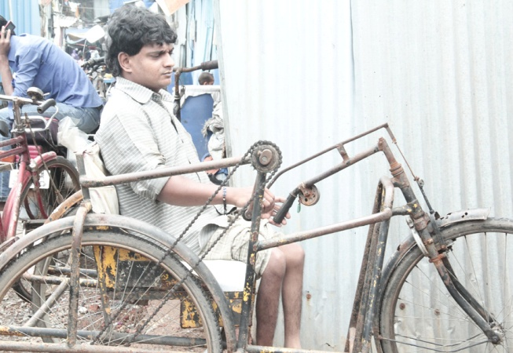
NAME: AFZAL ANWAR MEMON
GENDER: MALE
AGE: 30
AREA: Bhiwandi.
PERSONAL INFORMATION : A Polio patient works hard for survival if his family.
PROBLEMS:
1) Polio Patient.
2) House Problem.
3) children Educational Problem.
4) need tricycle
SOLLUTIONS:
1) Education welfare for both kids.
2) Medical Checkup.
3) House Facility.
4)tricycle cost 6580/-
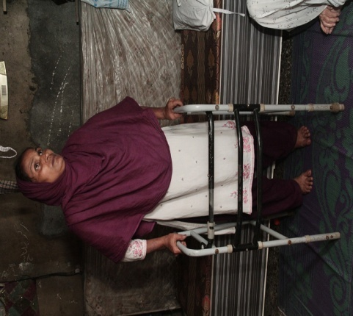
NAME: MUMTAZ SHAIKH
GENDER: FEMALE
AGE: 50
AREA: Bhiwandi.
PERSONAL INFORMATION: A widow, victim of a dangerous accident. Total family members are 5.
PROBLEMS:
1) She lost her both knees in an accident.
2) Her Daughter has spine problem.
3) House Problem.
3) Education Problem.

SOLUTIONS:
1) Education welfare for all kids.
2) Medical Checkup. (Treatment has started from an orthopedic surgeon.)
3) House Facility.

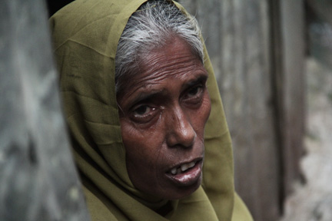
NAME: SAKEENA BANO.
GENDER: FEMALE
AGE: 60
AREA: Bhiwandi.
PERSONAL INFORMATION : A widow, having 3 girls. , out of which one is dead and her grand son is in Orphanage due to financial problem.
PROBLEMS:
1) House Problem.
2) Education Problem.
3) Work Problem.

SOLUTIONS:
1) Education welfare.
2) House Facility.
3) She wants to do the business of Imitation Jewelry and need 4000/- to strart.
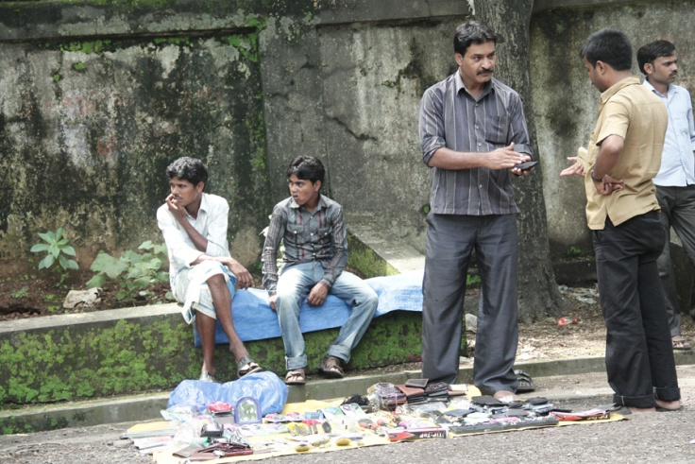
NAME: ABDUL AZIZ MEMON
GENDER: MALE
AGE: 50
AREA: Pathara.
PERSONAL INFORMATION: A vendor, living with a wife who is suffering from brain Tumor .
PROBLEMS:
1) Medical Problem.
2) House Problem.(Rs.130000 deposited for home and having home at rental basis. Rent is 700 per month.)

SOLUTIONS:
1) Medical Facility.(3000/month for medicine+2000/month for consultancy) i.e. 60000 per year+ 2 lacks for operation
2) House Facility. (He already got help of Rs.100000.b He can purchase his own house after paying from deposits and some of his own money, If he would get the help of Rs.100000
3) Quotation of store material is Rs.10344
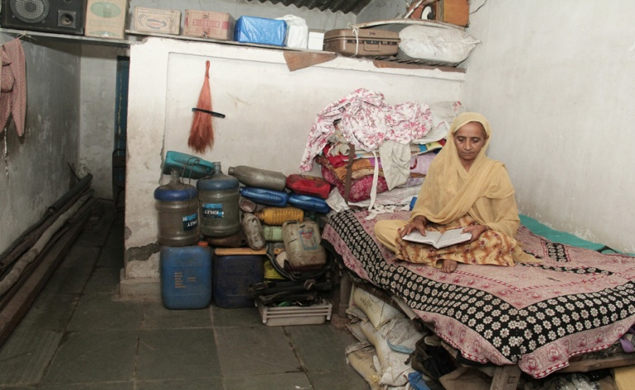
NAME: ZAIBUNNISA MEMON
GENDER: FEMALE
AGE: 55
AREA: Mahapoli.
PERSONAL INFORMATION: A widow, having Polio. Her daughter got married. Now she is living ALONE.
PROBLEMS:
1) Medical Problem.
2) House Problem.

SOLUTIONS:
1) Medical Facility.
2) House Facility.

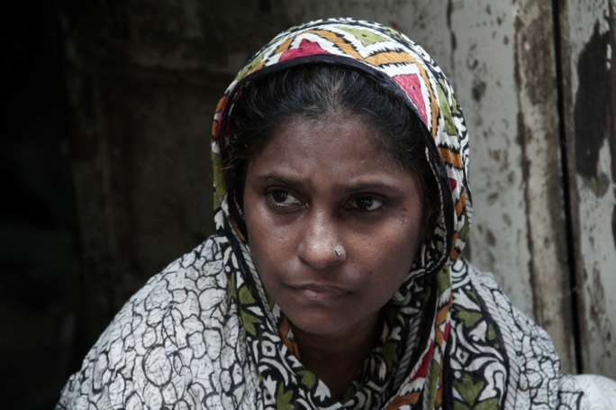
NAME: PARVEEN ASIF MEMON.
GENDER: FEMALE
AGE: 36
AREA: BHIWANDI.
PERSONAL INFORMATION: A widow, early got married. Having 4 kids (3 boys and a girl). Girl is studying in school. 1 son is in Orphanage 2 kids work with her.
PROBLEMS:
1) Education Problem for kids.
2) House Problem.
3) Seeking for work.

SOLUTIONS:
1) she wants to do Beautician Course. Total fee for course with material is around 4000 plus materials to start a parlour is 6000.total is 11000/-
2) House Facility. (2.5 lacks)
3) school fees. (Rs. 7000 for a girl)

NAME: MUNAF MEMON
GENDER: MALE
AGE: 55
AREA: Mumbra.
PERSONAL INFORMATION: A paralyzed patient, who sells Plastic combs to fulfill his basic needs.
PROBLEMS:
1) Seeking for suitable work.
2) House Problem.
3) Medical Help.
4) Education Help for kids.

SOLUTIONS:
1) Work Facility.
2) Medical welfare.
3) House Facility.
4) Educational Welfare.

NAME: SABERA MEMON
GENDER: FEMALE
AGE: 85
AREA: Akola.
PERSONAL INFORMATION: A widow who is a heart patient also. She cleans utensils and earns to fulfill her basic needs.
PROBLEMS:
1) Medical Treatment.
2) House Problem.

SOLUTIONS:
1) Medical welfare.
2) House Facility.

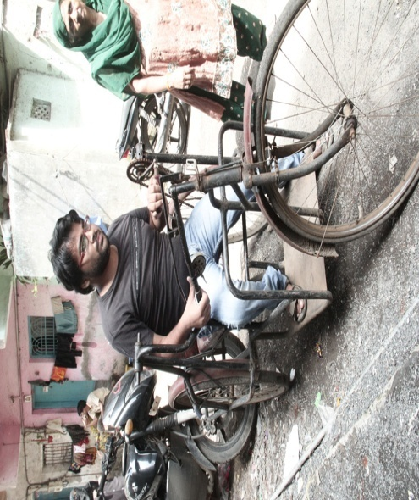
NAME: AQEEB JAVED FAROOQUI.
GENDER: MALE
AGE: 23
AREA: Bhiwandi.
PERSONAL INFORMATION: A polio patient who cleared IPCC- Group I. Doing Group B as well Teaching. Feeling helpless to do further studies due to travelling Problem.
PROBLEMS:
1) Travelling Problem.

SOLUTIONS:
1) Medical welfare.
3) Activa for travelling. (Rs. 65000 out of which he is ready to contribute Rs.10000. NET Amount is Rs.55000)

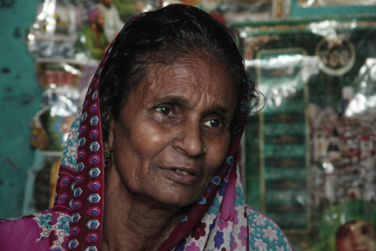
NAME: AYESHA ANWAR MEMON
GENDER: FEMALE
AGE: 60
AREA: Bhiwandi.
PERSONAL INFORMATION: A widow, seeking for work to fulfill her basic needs.
PROBLEMS:
1) Work Problem.

SOLUTIONS:
1) Providing House Facility.
2) Providing Work Facility.(she needs a shop where she can do small Trade)

